Alleppey Green Superior Cardamom – The Queen of Spices from India
Meta Description: Discover premium Alleppey Green Superior (AGS) Cardamom from The Export Express — India’s finest 8 mm bold pods with rich aroma and powerful flavor for global gourmet and wellness markets.

🌿 Introduction: The Queen of Spices
Fragrant, exotic, and steeped in centuries of culinary and cultural heritage — cardamom has rightfully earned its title as the Queen of Spices. Used in both sweet and savory dishes, traditional medicine, and aromatherapy, cardamom adds not just flavor but luxury.
At The Export Express, we bring you the finest 8 mm Alleppey Green Superior (AGS) Cardamom, cultivated in the lush highlands of Kerala, India. Our cardamom embodies purity, potency, and elegance — a spice that speaks of India’s agricultural excellence.

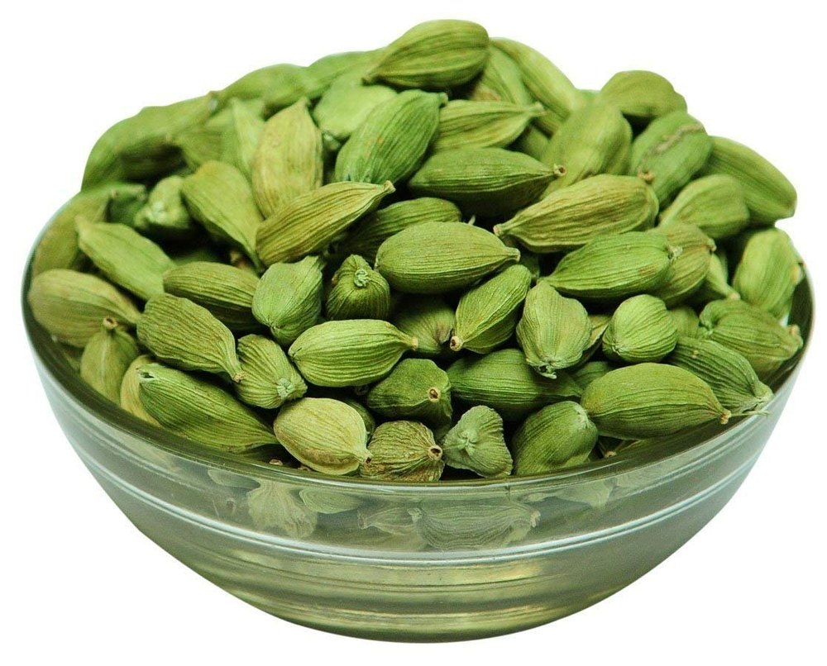
Caption: Hand-graded Alleppey Green Superior cardamom pods — uniform, bold, and rich in aroma.

🧾 Product Specifications
Parameter | Specification
Variety of Cardamom | Bold (Alleppey Green Superior – AGS)
Size | 8 mm
Packaging Size | 100 g / customized export sizes
Packaging Type | Plastic Bag / Vacuum Pack
Usage Application | Cooking, Baking, Herbal Teas, Perfume Blends
Organic | Yes
FSSAI Certified | Yes
Imported | No – 100 % Made in India
Country of Origin | India (Kerala Region)
Shelf Life | 18–24 months
Availability | In Stock

🌱 The Origin: Kerala’s Green Gold
The Alleppey region of Kerala is world-famous for producing the brightest green and most aromatic cardamom. Grown at altitudes of 800–1,200 m in misty hills, this variety benefits from fertile laterite soil, abundant monsoon rain, and traditional shade farming.
The result: large, plump pods (8 mm +) filled with fragrant black seeds that release a warm, camphor-citrus aroma when crushed.


Caption: Kerala’s Western Ghats — the heartland of India’s premium Alleppey Green Superior cardamom.

💚 Appearance & Flavor Profile
- Shape: Oval to spindle-shaped pods with smooth surface and tight skin.
- Color: Vivid green (a mark of freshness and natural curing).
- Aroma: Intense, sweet-spicy fragrance with hints of mint, eucalyptus, and citrus.
- Taste: Warm, slightly pungent, with a cooling after-note.
This aromatic balance makes AGS Cardamom a prized choice for chefs, beverage formulators, and herbal product manufacturers worldwide.

🍴 Culinary & Global Uses

1. Indian Cuisine
Cardamom enhances both savory and sweet dishes — from biryani and korma to kheer, gulab jamun, and masala chai.

2. Global Gourmet Recipes
- Middle East: Used in Arabic coffee (Qahwa) and sweets.
- Scandinavia: Key ingredient in pastries and spiced bread.
- USA & Europe: Found in lattes, desserts, and premium chocolates.

3. Wellness & Ayurveda
Known as Elaichi in Ayurveda, cardamom balances Vata and Kapha doshas, aiding digestion, freshening breath, and soothing the respiratory system.

4. Aromatherapy & Cosmetics
Essential oil from AGS Cardamom is used in perfumery, mouthwashes, and herbal formulations for its uplifting aroma.

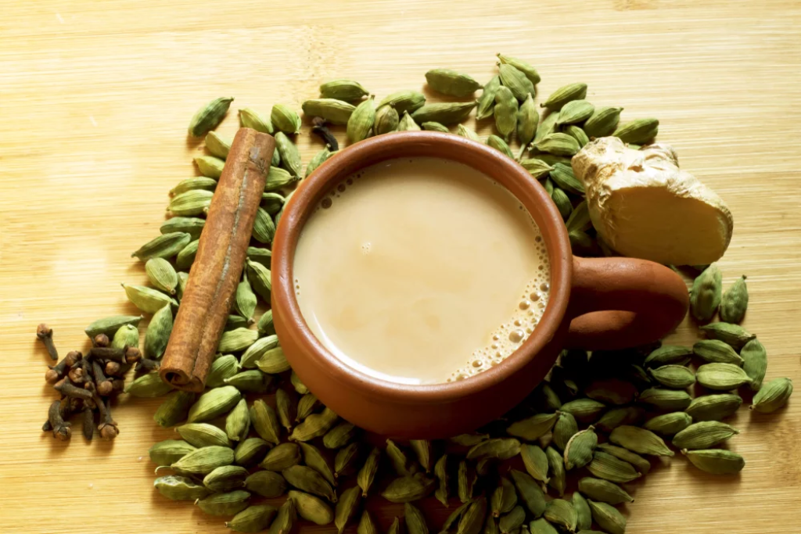
Caption: Green cardamom adds depth to teas, coffees, desserts, and herbal wellness blends.

🩺 Health Benefits of Cardamom

1. Digestive Health
Cardamom promotes gastric balance, relieves acidity, and improves digestion.

2. Respiratory Relief
Its expectorant properties ease cough, congestion, and bronchitis.

3. Antioxidant Power
Rich in phytochemicals like cineole and terpenes that combat oxidative stress.

4. Oral & Dental Health
Natural antibacterial agents in cardamom help freshen breath and protect gums.

5. Detox & Heart Support
Cardamom assists in detoxification, helps regulate blood pressure, and supports cardiovascular health.

🌿 Ayurveda Insight
In classical Ayurveda, cardamom (Elettaria cardamomum) is regarded as a “sattvic” spice — one that elevates clarity and positivity.
It is often prescribed in formulations for:
- Appetite stimulation
- Respiratory cleansing
- Digestive tonics (Trikatu blends)
- *Mood enhancement through aroma therapy

📊 Nutritional Snapshot (per 100 g – approx.)
Nutrient | Value
Energy | 311 kcal
Carbohydrates | 68 g
Protein | 11 g
Fat | 7 g
Fiber | 28 g
Calcium | 380 mg
Iron | 14 mg
Magnesium | 230 mg

🏭 Why Choose The Export Express

Premium Sourcing
Sourced directly from Kerala’s Alleppey estates for consistent AGS grade quality.
Expert Grading & Cleaning
Hand-sorted pods, screened for size (8 mm +) and uniform color.

Global Export Standards
FSSAI, ISO 9001, and GMP-compliant handling and packaging.

Flexible Packaging & Private Labeling
Custom sizes for B2B and retail — with OEM/white-label options.

Sustainability Commitment
Ethically sourced, supporting local farmers and eco-friendly practices.

📦 Packaging Options
Type | Size | Material | Purpose
Plastic Bag | 100 g – 1 kg | Retail Packs | Retail/Online Sales
Vacuum Sealed Bag | 500 g – 5 kg | Food-grade Barrier Film | Preserve Aroma & Freshness
Jute Bag | 25 kg | Export Bulk | Commercial Distribution

🌏 Export Excellence
As a certified Indian cardamom exporter, The Export Express delivers to markets across:
UAE · Saudi Arabia · Europe · North America · Japan · Australia
Our AGS Cardamom meets global spice board standards for moisture, color, and aroma — ensuring long shelf life and authentic taste.

🌿 Conclusion
From the ancient spice routes to modern kitchens, Alleppey Green Superior Cardamom continues to reign as the Queen of Spices — fragrant, flavorful, and full of vitality.
At The Export Express, we uphold India’s spice legacy through our dedication to purity, sustainability, and global quality. Whether for gourmet cooking, tea blends, or health formulations, our 8 mm AGS Cardamom delivers an experience worthy of royalty.

Keywords: cardamom exporter India, Alleppey green cardamom AGS, bold cardamom 8 mm, herbal export India, Indian spices export, The Export Express.

